  - Screen Shots
  - Screen 1: My Investigation applet

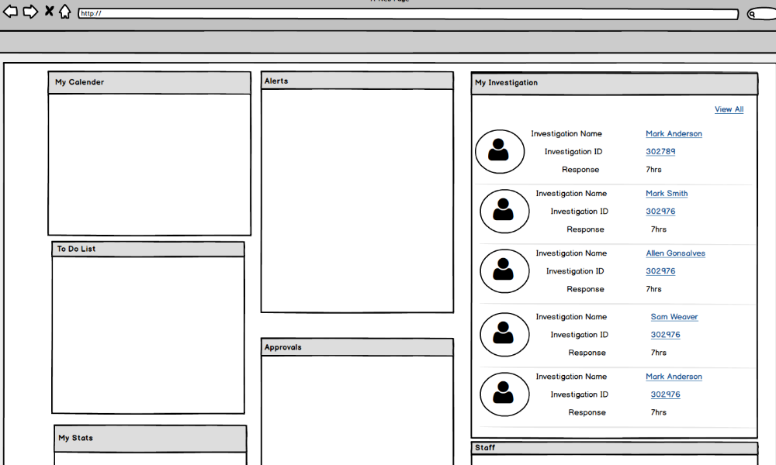

1.1.1 Name fields
Class.Attribute Name | Display Name | Type | Align | Size | Read Only | Calculation | Edit Mask | UI Validation
 | My Investigation | Applet | L |  | T |  |  | Applet on MY Organizer screen
INVESTIGATION.investigationId | Investigation ID | Display text | L | 22 | T | N/A | N/A | All Open Investigations will be displayed here
INVESTIGATION_PERSON.  PERSON.LASTNAME+FIRSTNAME+MIDDLENAME | Investigation Name | Display text | L | 110 | T | Populate name taken from Investigation Persons List grid where the record was flagged “Investigation Name. | N/A | Name in standardized UI format
INVESTIGATION.responseDueDateTime | Due Date | Display text | L | 10 | T | N/A | UI Standardized Date  MM/DD/YYYY hh:mm AM/PM (ET/CT)

    - Action Buttons/Hyperlinks
Label | Type | On Click Action/Navigation
Investigation ID | Hyperlink | The hyperlink will take the user to the Investigation Overview screen. Screen 1 of IV20.
View All | Link | On clicking ‘View All’, the Investigation->Workload will be displayed with all the Open investigations (Screen 2 of this user story)

  - Screen 2: InvestigationWorkload Screen

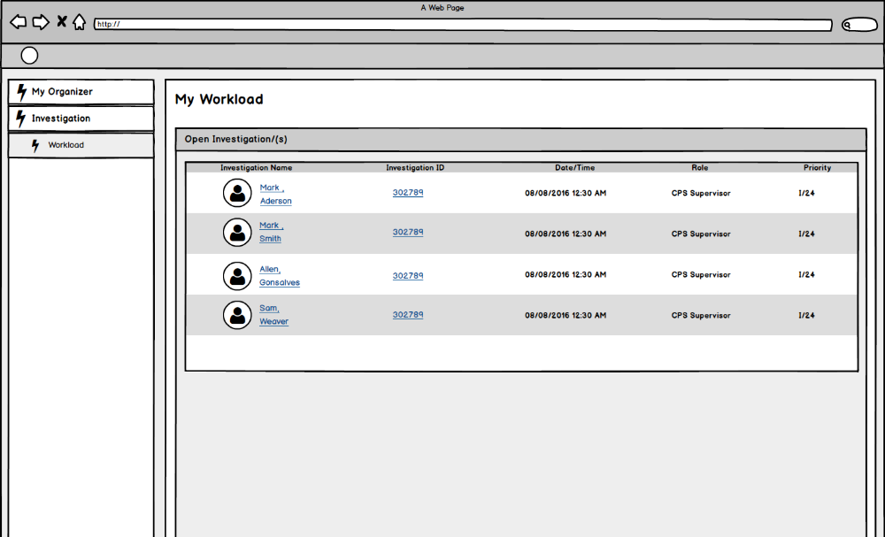
Notes: Delete Roles field in the table

1.2.1 Screen Fields
 | Display Name |  |  | Size
Class.Attribute Name | Display Name | Type | Align | Size | Read | Calculation | Edit Mask | UI Validation
 | Display Name |  |  | Size | Only
CaseCategory.caseCategoryCode | Investigation Cases | Expando | L | 100 | F | System will group case assignment by Case Category code |  | All open investigations will be displayed
INVESTIGATION_PERSON.  PERSON.LASTNAME+FIRSTNAME+MIDDLENAME | Investigation Name | Display text | L | 110 | T | Populate name taken from Investigation Persons List grid where the record was flagged “Investigation Name. | N/A | Name in standardized UI format
INVESTIGATION.investigationId | Investigation ID | Display text | L | 22 | T | N/A | N/A | N/A
Intake.received_date | Complaint Date/Time | Display Text | L | N/A | T | N/A
INTAKE.currentPriority | Priority | Display text | L | 30 | T | domain code=IntakePriority |  | Priority of the linked intake

    - Action Buttons/Hyperlinks

Label | Type | On Click Action/Navigation
Investigation ID | Hyperlink | On clicking the hyperlink, Investigation Overview screen is displayed. Launches IV20-User Story 232.

  - Story

As a caseworker, I need the system to display all of my active case assignments so that I can perform necessary case tasks.

  - Notes

3.1 Points to Note

  - Demo Steps
To view the Investigations linked to an Intake
- Step 1: Login to the USFN application with the following credentials
  - Username: samweaver
  - Any Password works.
‘My Organizer’ screen is displayed after successful login.
- Step 2: Click on ‘View All’ from the “My Investigation” applet.
Investigation->Workload is displayed by default.
- Step 3: All the Open Investigations for the user is displayed (as per Screen 1 of this user story is displayed)

  - Acceptance Criteria
  - Screen 1

# | Requirement | Execution Event | Status
1 | All Open Investigations should be displayed in the Investigation->Workload screen | On clicking Save
2 | The sort order of the Investigations will be based on the alphabetical order of the Last Name | Display

  - Seed Data
Dropdown data.

  - Tables Required

These are the tables that are required as per the user story. However, there might be additional tables that may be required at the backend.

CASE_CATEGORY

INVESTIGATION

INVESTIGATION_PERSON

ROLE

INTAKE

